Camping Manager

Analysis and Design Document

Student:Cîmpan Roxana-Adriana

**Group:30233**

Revision History

|  |  |  |  |
| --- | --- | --- | --- |
| **Date** | **Version** | **Description** | **Author** |
| 06/apr/17 | 1.0 | Domain Model  Architectural Design  Component and Deployment diagrams | Cîmpan Roxana-Adriana |
|  |  |  |  |
|  |  |  |  |
|  |  |  |  |

Table of Contents

I. Project Specification 4

II. Elaboration – Iteration 1.1 4

1. Domain Model 4

2. Architectural Design 4

2.1 Conceptual Architecture 4

2.2 Package Design 4

2.3 Component and Deployment Diagrams 4

III. Elaboration – Iteration 1.2 4

1. Design Model 4

1.1 Dynamic Behavior 4

1.2 Class Design 4

2. Data Model 4

3. Unit Testing 4

IV. Elaboration – Iteration 2 4

1. Architectural Design Refinement 4

2. Design Model Refinement 4

V. Construction and Transition 5

1. System Testing 5

2. Future improvements 5

VI. Bibliography 5

# Project Specification

*[Present the project specification]*

# Elaboration – Iteration 1.1

# Domain Model

Proiectul implementat are doua tipuri de utilizatori. Fiecare dintre acestia au propriile operatii pe care le pot efectua. Prin umare prezint cei doi utilizatori:

1. -**user regular** (**user normal**)

-poate sa rezerve casute din incinta camping-ului(pentru rezervare va fi necesar sa completeze anumite campuri, de exemplu: nume, prenume, adresa, numar de telefon, adresa de mail).

-poate sa vizualizeze fotografiile disponibile intr-un album photo

-poate sa lase comentarii, observatii, reclamatii, sugestii sau aprecieri

-poate sa vizualizeze casutele care sunt disponibile

-poate sa vizualizeze perioada in care este ocupata o anumita casuta

1. -**administrator**:

-poate sa vizualizeze comentariile, observatiile, reclamatiile, sugestiile sau aprecerile

-poate sa vizualizeze anumite rapoarte despre casuta

-poate sa stearga anumite rezervari

# Architectural Design

## Conceptual Architecture

Una dintre arhitecturile pe care doresc sa o utilizez: 3-tier. Aceasta este o arhitectura client-server. Aceasta arhitectura se bazeaza pe:

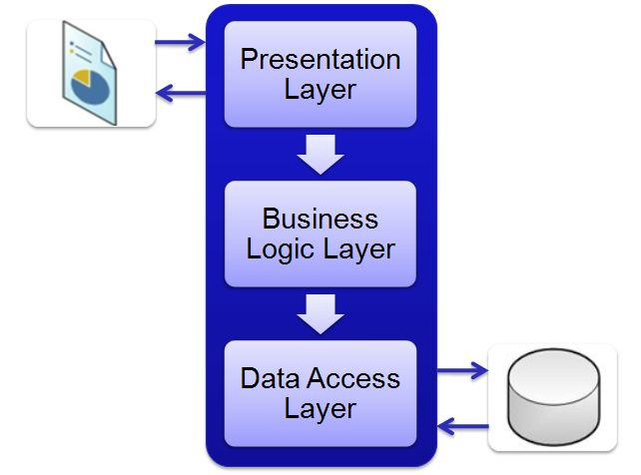

1.Presentation tier

2.Bussines Logic tier

3.Data tier

* Presentation tier=UI layer

-reprezinta nivelul superior al aplicatiei

-mai précis, este layerul la care utilizatori pot avea acces direct (pagina WEB sau GUI-in cazul proiectului de fata)

* Bussines Logic tier

-controleaza functionalitatea unei aplicatii

* Data tier

-include mecanisme de persistenta

* Fisiere partajate
* Servere da baze de date

-layer-ul de acces incapsuleaza mecanismele de persistenta

* Codul pentru fiecare layer terbuie sa fie in fisiere separate care pot fi mentinute separate
* Fiecare layer poate cantine numai cod care face parte din acel layer
* bussines logic se poate afla numai in Bussines layer
* presentation logic se poate afla numai in Presentation layer
* data acces logic se poate afla numai in Data Acces Layer

## Package Design

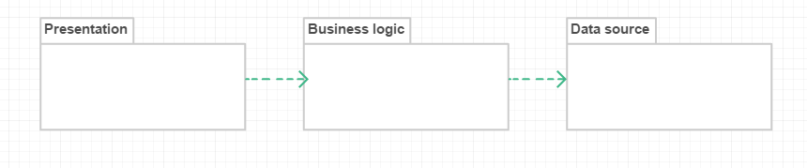

## Component and Deployment Diagrams

# 

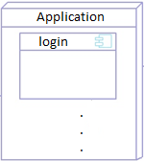

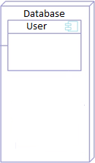



# Elaboration – Iteration 1.2

# Design Model

## Dynamic Behavior

*[Create the interaction diagrams (1 sequence, 1 communication diagrams) for 2 relevant scenarios]*

## Class Design

*[Create the UML class diagram; apply GoF patterns and motivate your choice]*

# Data Model

*[Create the data model for the system.]*

# Unit Testing

*[Present the used testing methods and the associated test case scenarios.]*

# Elaboration – Iteration 2

# Architectural Design Refinement

*[Refine the architectural design: conceptual architecture, package design (consider package design principles), component and deployment diagrams. Motivate the changes that have been made.]*

# Design Model Refinement

## *[Refine the UML class diagram by applying class design principles and GRASP; motivate your choices. Deliver the updated class diagrams.]*

# Construction and Transition

# System Testing

*[Describe how you applied integration testing and present the associated test case scenarios.]*

# Future improvements

*[Present future improvements for the system]*

# Bibliography

<http://www.tonymarston.net/php-mysql/3-tier-architecture.html#3-tier>

<https://www.techopedia.com/definition/24649/three-tier-architecture>

<https://www.google.ro/search?q=model+view+controller+package+design&source=lnms&tbm=isch&sa=X&ved=0ahUKEwjFtcnCkY7TAhWMhSwKHfuwBgEQ_AUIBigB&biw=1366&bih=613#imgrc=_>